Ant-Racism & Pro-Reconciliation Ministry

Books to Read Right Now If You Want to Be Anti-Racist

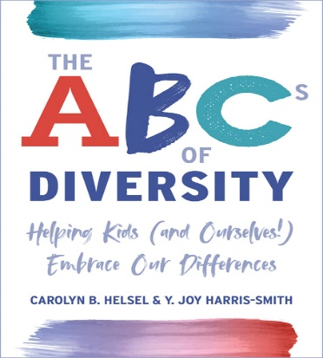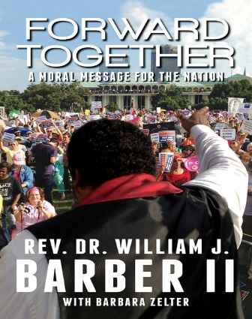

The ABCs of Diversity: Helping Kids Forward Together:

(and Ourselves!) Embrace Our Differences A Moral Message for the Nation

By Carolyn B. Helsel, Y. Joy Harris-Smith By Reverend Dr. William Barber II,

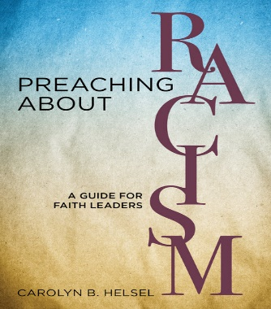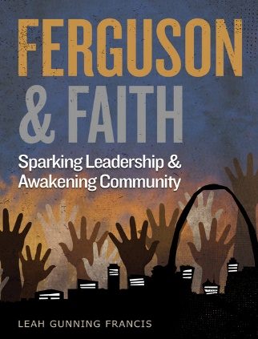
Preaching about Racism: Ferguson and Faith:
A Guide for Faith Leaders Sparking Leadership and Awakening Community
By Carolyn B. Helsel By Leah Gunning Francis

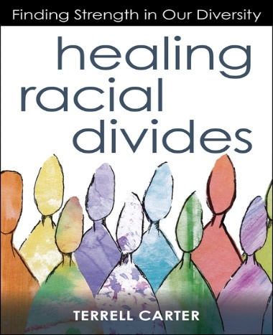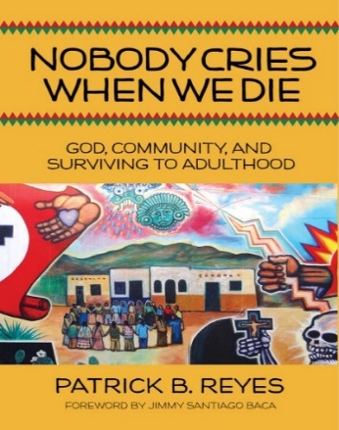

Healing Racial Divides: Nobody Cries When We Die:

Finding Strength in Our Diversity, God, Community, and Surviving

By Terrell Carter to Adulthood, By Patrick B. Reyes

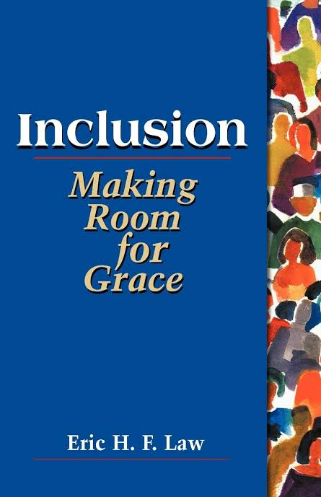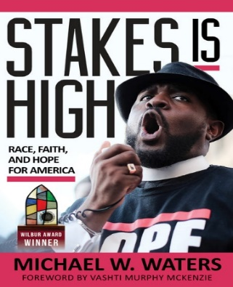

Inclusion: Making Room for Grace Stakes Is High: Race, Faith,

And Hope for America

By Michael W. Waters

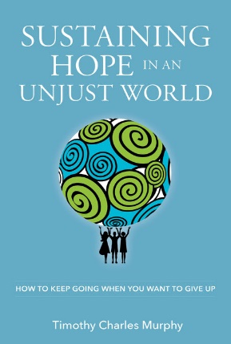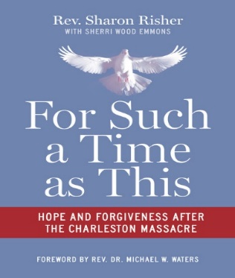

Going When You Want to Give Up For Such a Time as This: Hope and

By Timothy Charles Murphy Forgiveness after the Charleston Massacre,

By Sharon Risher with Sherri Wood Emmons

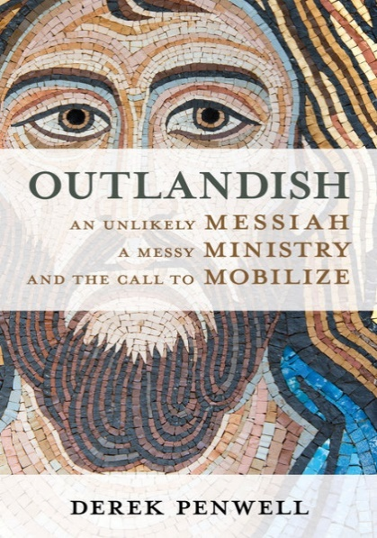

Outlandish: An Unlikely Messiah, a Messy Ministry,

and the Call to Mobilize, By Derek Penwell

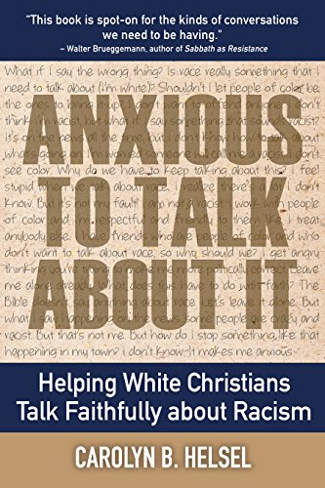
By: Carolyn B. Helsel

