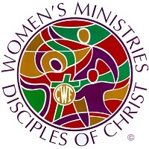 2023 VIRGINIA DISCIPLE WOMEN
OFFERING REMITTANCE FORM

DWM/CWF NAME: ________________________________________________________________
CHURCH NAME:_________________________________________________________________
CHURCH ADDRESS: ______________________________________________________________
CITY/STATE: ______________________________________ZIP: __________________________

NAME OF OFFERING | AMOUNT
DWM Blessing Box | $
DWM Woman to Woman | $
DWM Scholarship  (fund for VA Woman Seminary studies | $
DWM Spring Project – (designate specifically)  Local - Craig Springs  Global – Week of Compassion | $
DWM Cabinet Support – Virginia Region  Includes – Women’s Retreat Expenses, DW/CWF Materials, Misc. | $
TOTAL | $

Please include this form with your offerings. Checks must be made payable to: CCINVA

Mail Checks to:
OGMP Treasury Services
PO Box 1986
Indianapolis, IN 46206-1986
Or
CCINVA
1290 Enterprise Drive
Lynchburg, VA 24502

All 2023 offerings must be received by or post-dated by Dec. 31, 2023.
Any offering received or post-dated after Dec. 31, 2023 will be credited to 2024 offerings.

